1. Retrieve the count of Successful and cancelled bookings:

SELECT

Booking_Status,

COUNT(*) as count,

ROUND((COUNT(*) * 100.0 / (SELECT COUNT(*) FROM OLA_data)),1) as Percentage

FROM OLA_data

GROUP BY Booking_Status;

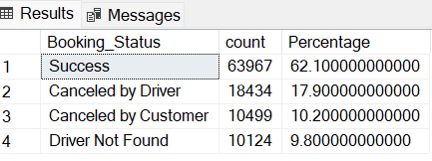

1. Find the average ride distance for each vehicle type:

SELECT Vehicle_Type, ROUND(AVG(Ride_Distance),1) as avg_distance

FROM OLA_data

GROUP BY Vehicle_Type;

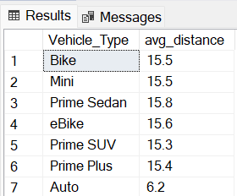

3. List the top 5 customers who booked the highest number of rides:

SELECT Customer_ID, total_rides

FROM ( SELECT Customer_ID, COUNT(Booking_ID) as total_rides,

ROW_NUMBER() OVER (ORDER BY COUNT(Booking_ID) DESC) as row_num

FROM OLA_data GROUP BY Customer_ID) as ranked

WHERE row_num <= 5;

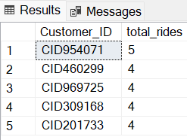

4. Get the number of rides cancelled by drivers for each reason.

SELECT Canceled_Rides_by_Driver, COUNT(*) as Count_of_Rides_cancelled

FROM OLA_data

WHERE Canceled_Rides_by_Driver != 'null'

GROUP BY Canceled_Rides_by_Driver

ORDER BY 2 DESC;

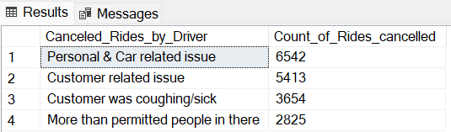

5. Find the maximum and minimum driver ratings for each vehicle type

SELECT Vehicle_Type, MAX(Driver_Ratings) as max_rating, MIN(Driver_Ratings) as min_rating

FROM OLA_data

WHERE Driver_Ratings != 'null'

GROUP BY Vehicle_Type;

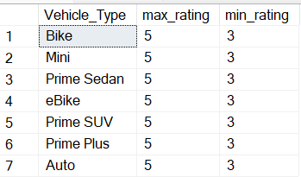

6. Retrieve the count of all rides for each payment type:

SELECT Payment_Method, COUNT(*) as Count_of_payments

FROM OLA_data GROUP BY Payment_Method

ORDER BY 2 DESC;

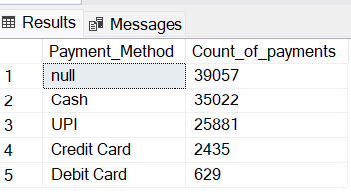

7. Find the average customer rating per vehicle type:

SELECT Vehicle_Type, ROUND(AVG(Customer_Rating),2) as avg_customer_rating

FROM OLA_data GROUP BY Vehicle_Type;

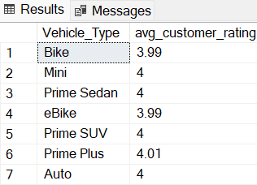

8. Calculate the total booking value of rides completed successfully:

SELECT SUM(Booking_Value) as total_successful_value

FROM OLA_data

WHERE Booking_Status = 'Success';

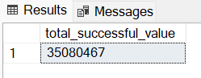

9. List count of incomplete rides for each reason type.

SELECT Incomplete_Rides_Reason, COUNT(*) as Count_of_rides

FROM OLA_data WHERE Incomplete_Rides ='Yes'

GROUP BY Incomplete_Rides_Reason;

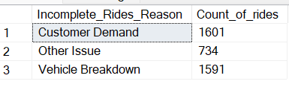

10. **Calculate the Average Booking Value by Vehicle Type and Pickup Location:**

SELECT Pickup_Location,

ISNULL([Auto], 0) as Auto,

ISNULL([Bike], 0) as Bike,

ISNULL([Mini], 0) as Mini,

ISNULL([eBike], 0) as eBike,

ISNULL([Prime Sedan], 0) as [Prime Sedan],

ISNULL([Prime SUV], 0) as [Prime SUV],

ISNULL([Prime Plus], 0) as [Prime Plus]

FROM (

SELECT Vehicle_Type, Pickup_Location, Booking_Value

FROM OLA_data

WHERE Booking_Status = 'Success'

) as source

PIVOT (

AVG(Booking_Value)

FOR Vehicle_Type IN ([Auto], [Bike], [Mini], [eBike], [Prime Sedan], [Prime SUV], [Prime Plus])

) as pvt

ORDER BY Pickup_Location;

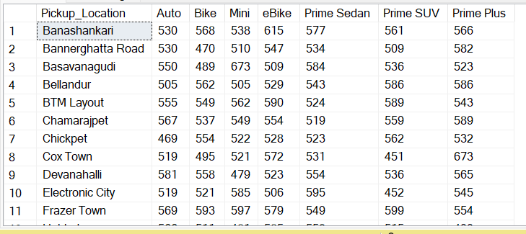

11. Analyse the Distribution of Customer Ratings, number of rides and revenue Across Different Time Slots:

SELECT

CASE

WHEN DATEPART(HOUR, Time) BETWEEN 5 AND 11 THEN 'Morning'

WHEN DATEPART(HOUR, Time) BETWEEN 12 AND 15 THEN 'Afternoon'

WHEN DATEPART(HOUR, Time) BETWEEN 16 AND 19 THEN 'Evening'

WHEN DATEPART(HOUR, Time) BETWEEN 20 AND 23 THEN 'Night'

ELSE 'Midnight'

END as time_slot,

AVG(Customer_Rating) as avg_customer_rating,

COUNT(*) as total_rides,

SUM(Booking_Value) as Revenue

FROM OLA_data

WHERE Booking_Status = 'Success'

GROUP BY CASE

WHEN DATEPART(HOUR, Time) BETWEEN 5 AND 11 THEN 'Morning'

WHEN DATEPART(HOUR, Time) BETWEEN 12 AND 15 THEN 'Afternoon'

WHEN DATEPART(HOUR, Time) BETWEEN 16 AND 19 THEN 'Evening'

WHEN DATEPART(HOUR, Time) BETWEEN 20 AND 23 THEN 'Night'

ELSE 'Midnight' END

ORDER BY total_rides DESC;

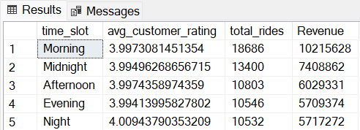

12. Identify peak hours for each vehicle type across different time slots

SELECT

Vehicle_Type,

SUM(CASE WHEN DATEPART(HOUR, Time) BETWEEN 5 AND 11 THEN 1 ELSE 0 END) as Morning,

SUM(CASE WHEN DATEPART(HOUR, Time) BETWEEN 12 AND 16 THEN 1 ELSE 0 END) as Afternoon,

SUM(CASE WHEN DATEPART(HOUR, Time) BETWEEN 17 AND 21 THEN 1 ELSE 0 END) as Evening,

SUM(CASE WHEN DATEPART(HOUR, Time) BETWEEN 21 AND 23 THEN 1 ELSE 0 END) as Night,

SUM(CASE WHEN DATEPART(HOUR, Time) BETWEEN 0 AND 4 THEN 1 ELSE 0 END) as Midnight

FROM OLA_data

WHERE Booking_Status = 'Success'

GROUP BY Vehicle_Type

ORDER BY Vehicle_Type;

